Engineering Research and Education Workshop
Speaker: Eugene Rutz, MS, PE is an Academic Director in the College of Engineering & Applied Science at the University of Cincinnati. Eugene has oversight of the combined Bachelor's and Master's programs, the Master of Engineering programs and the collaborative program with regional high schools.
Date: Thursday, July 7, 2016
Venue: University of Cincinnati, Zimmer Hall, room 516
Prepared by:
Nancy A. Schreder-Vossen, William Henry Harrison High School, Harrison, Ohio
RET Participant for Project #1: Application of Nanocomposites on Controlling Biofilms in Drinking Water Distribution Systems

The objectives for the presentation given by Mr. Rutz were to discuss engineering education and differentiate between research and the engineering design process. He began his presentation by outlining his objectives and having each member in the attendance briefly introduce themselves. Audience members introduced themselves by stating their school, the subject area(s) they taught, and the RET project they are participating in. The introduction format set the tone for the presentation, as he stated he wanted group dialogue as he presented his informati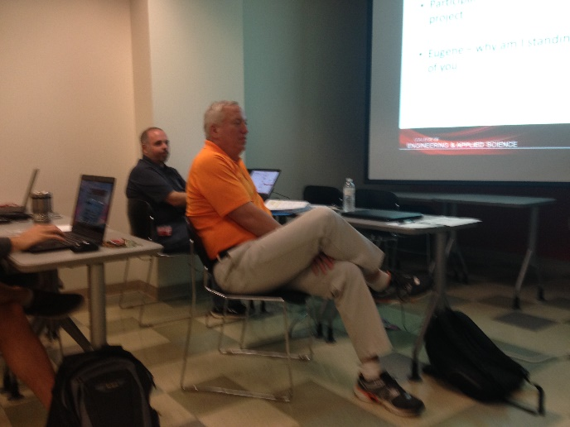 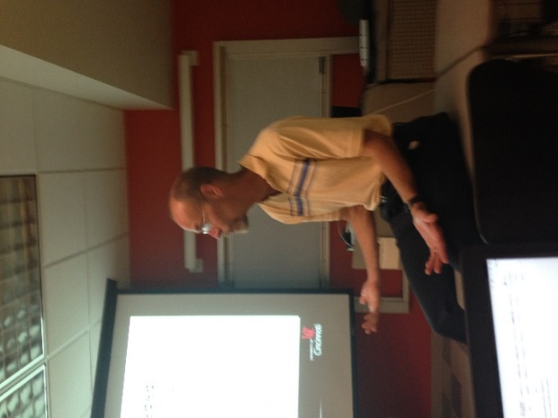
Figure 1: RET students introduces themselves to Mr. Rutz Figure 2: Mr. Rutz leads the STEM discussion

Mr. Rutz began the informative part of his presentation by asking the participants to define STEM (science, technology, engineering, mathematics), and comment on how it can be applied to the work they do in their classroom. The second topic of discussion revolved around defining the term engineering and how it relates to technology. The group discussed both topics and came to the conclusion that: a) math is a language that has rules that do not change b) engineering is a process that encourages problem solving c) the term technology relates to the tools that are used to achieve the goals of STEM education and d) STEM is a way of teaching topics that integrate science, technology, engineering, and math. The audience spent time discussing how to integrate engineering and math into the content standards and school district expectations. All members appeared to agree that STEM is a teaching method that can be utilized by teachers to teach content and help students explore different career opportunities.
The presentation given by Mr. Rutz provided information regarding the job outlook for individuals entering the engineering field, the demands of being an engineering student, how teachers can help students prepare so they can get accepted into an engineering program, and misconceptions related to the field of engineering. During this part of the presentation, one member of the audience commented on the importance of educating students about the different career choices available within a certain branch of engineering. Mr. Rutz agreed with this statement and took it one step further by explaining that earning an Engineering degrees provide an individual with a skill set that can be applied to different occupations and career choices.
Mr. Rutz concluded his presentation by asking the audience to compare and contrast research and the engineering design process. The audience concluded that the main difference between the two is that research follows the scientific method and ends with a specific answer. In contrast, the engineering design process allows for multiple answers. According to Mr. Rutz, the most critical components of the engineering design process are understanding what the real problem is and identifying alternatives that meet the constraints. He spent time discussing the importance of identifying what the real constraints are that inhibit the alternative choice from being used. He also stated that it is critical to understanding that each situation has a best solution. After a short group discussion, the audience members and Mr. Rutz determined that simple test can be done to determine if one is teaching Research or the Engineering Design Process. The test that could be done to determine if one is teaching Research or the Engineering Design Process is to ask a question. If the teacher wants all students to get the same answer, it is research. If there are multiple solutions it is most likely the Engineering Design Process.

